Dependency Injection

Normally, a class depends on another class to do some work, for example:
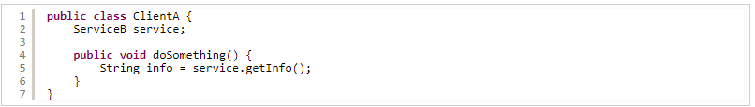
Here, class ClientA uses class ServiceB which is written as below, for example:
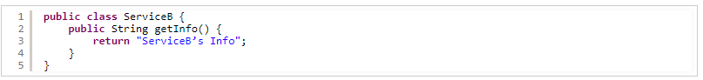
The class ClientA is said to be dependent on the class ServiceB, and ServiceB is called a dependency of ClientA. .

- The code is inflexible - it’s hard to maintain and extend as when a class permanently depends on another class, change to the depending class my require change to the dependent class. And it’s impossible to change the depending class later without updating and re-compiling the code.
- The code is hard for unit testing because when you want to test only the functionalities of a class, you have to test other depending classes as well.
- The code is hard for reuse because the classes are tightly coupled.
First, interfaces are used to define the types of the classes so its implementation can be changed later. For example, with the above code - the interfaces Client and Service are introduced:
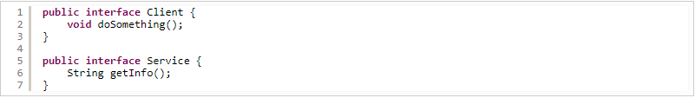
Then the ServiceB class becomes an implementation of Service as below:
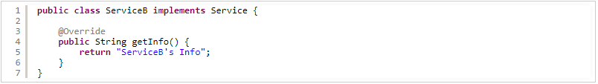
Then it’s possible to have different implementations of Service, for example ServiceC and ServiceD:
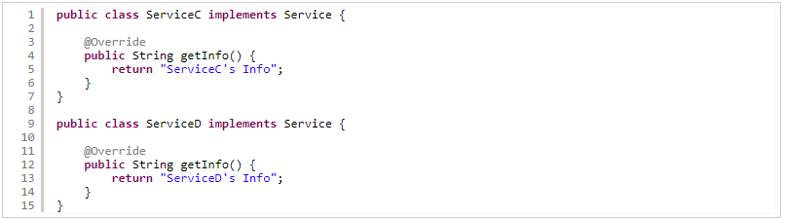
And the class ClientA is now implementing the Client interface and it uses the Service interface instead of a concrete class - the actual Service’s implementation is “injected” to this class via its constructor - constructor injection, as shown below:
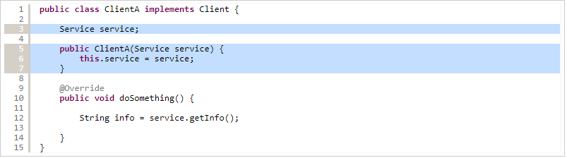
The class ClientA is now not depending on any specific implementations of Service. Instead of creating an instance of dependent class directly in ClientA, the dependency injection container or framework is now responsible for creating that instance and inject it to the class ClientA via its constructor. For example:
Here, an implementation of Service is ServiceB is created and passed to ClientA, which is not aware of the actual implementation it is using. ClientA only knows that the injected object is of type Service.
Besides constructor injection, setter injection is used to pass the depending object to the dependent one. Add the following setter method in the ClientA class:
Then we can change to different Service’s implementation e.g. ServiceC like this:

